IIS Mover User’s Guide

Chad Weirick

Table of Contents

Installation 2

Overview 2

General Usage 2

Task Screenshots and Overview 3

Wait Task 4

Compress Task 5

Copy Task 6

App Pool Task 6

API Call Task 7

Saving and Loading 7

|  |
| --- |
| Installation |

Installation of IIS Mover is covered in the administrator’s guide. Please see your network/systems administrator for assistance.

|  |
| --- |
| Overview |

IIS Mover is designed to assist with common tasks encountered when moving IIS instances. These tasks currently include:

* Compressing files (for backups or ease of movement).
* Copying files.
* Starting/Stopping application pools.
* Making API calls.
* A generic message/wait period for tasks outside the above-listed scope.

|  |
| --- |
| General Usage |

Upon loading IIS Mover, the main window of IIS Mover will appear:

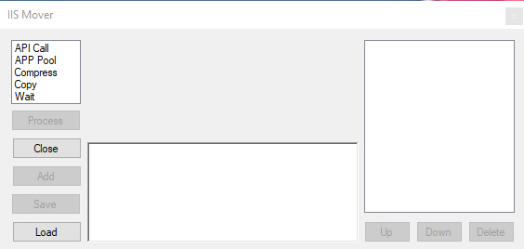

From here you can exit, start populating the task list, or load a pre-made task list. Once you have populated tasks in the task list, you can also sort and save. The following buttons are contextual and will not work unless appropriate:

* Process - Must have at least 1 task on the list.
* Add - Must have a valid task completely filled out.
* Save - Must have at least 1 task on the list.
* Up – Must have at least 2 tasks on the list and cannot have selected the top task.
* Down – Must have at least 2 tasks on the list and cannot have selected the bottom task.
* Remove - Must have at least 1 task on the list.

|  |
| --- |
| Task Screenshots and Overview |

Once a task has been populated in the list, selecting that task will show its contents:

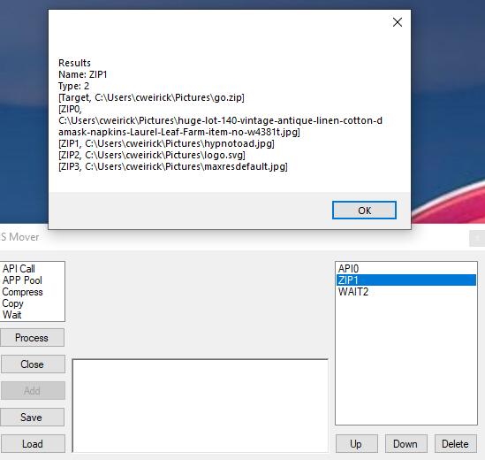

The following screen shots show the respective tasks:

#### Wait Task

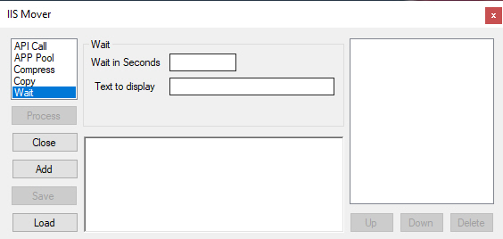

The Wait task will throw up a system message dialog box with the contents of then ‘Text to display’ field. The concept here is that there may be tasks outside of the scope of IIS Mover to accomplish. For example, it may be possible to send files to a folder on a REST server, however it may require human intervention to stop application pools on that remote server. So a message could state something such as ‘Please turn the testRS app pool off on the ourcompanyRS server before clicking ok.’ This is what the end user will see.

#### Compress Task

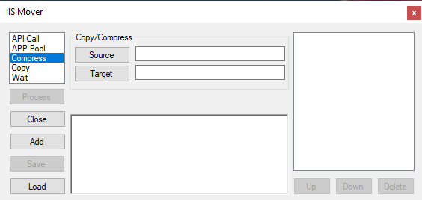

The Compress task allows the user to select source files and a target file. Source files will be compressed into the target file. Selecting source does not permit folder copying, so this will need to be done on a per-folder basis. The reason behind this is that some IIS applications (if not most) have files such as a web.config which are not desirable to copy as different instances populate these particular files in different ways.

#### Copy Task

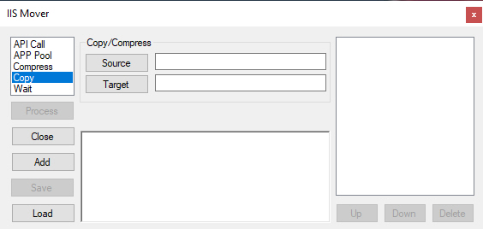

Copy will initiate a copy of selected files to a target folder.

#### App Pool Task

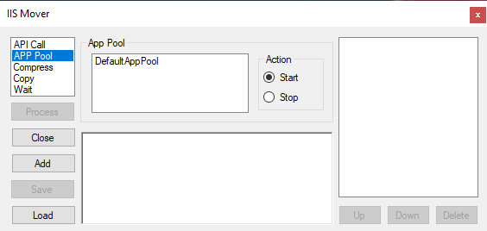

App pool will list the available app pools and provide the ability to start or stop them.

#### API Call Task

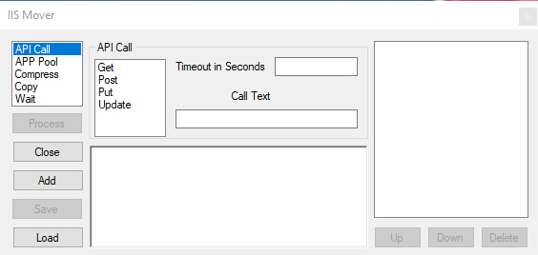

API call allows for the processing of basic API calls which are static. Now dynamic content is supported.

|  |
| --- |
| Saving and Loading |

Once a task list has been assembled, it can be saved. Once saved, it can be loaded. These are both handled via the Save and Load buttons respectively. Moving IIS instances requires a high degree of repeatability of often complex steps. The Save and Load functions are critical to accomplishing this task.